**Agile and Jira Project (Othoba.com)**

**1. Go to the url “othoba.com” and click on “Register”**

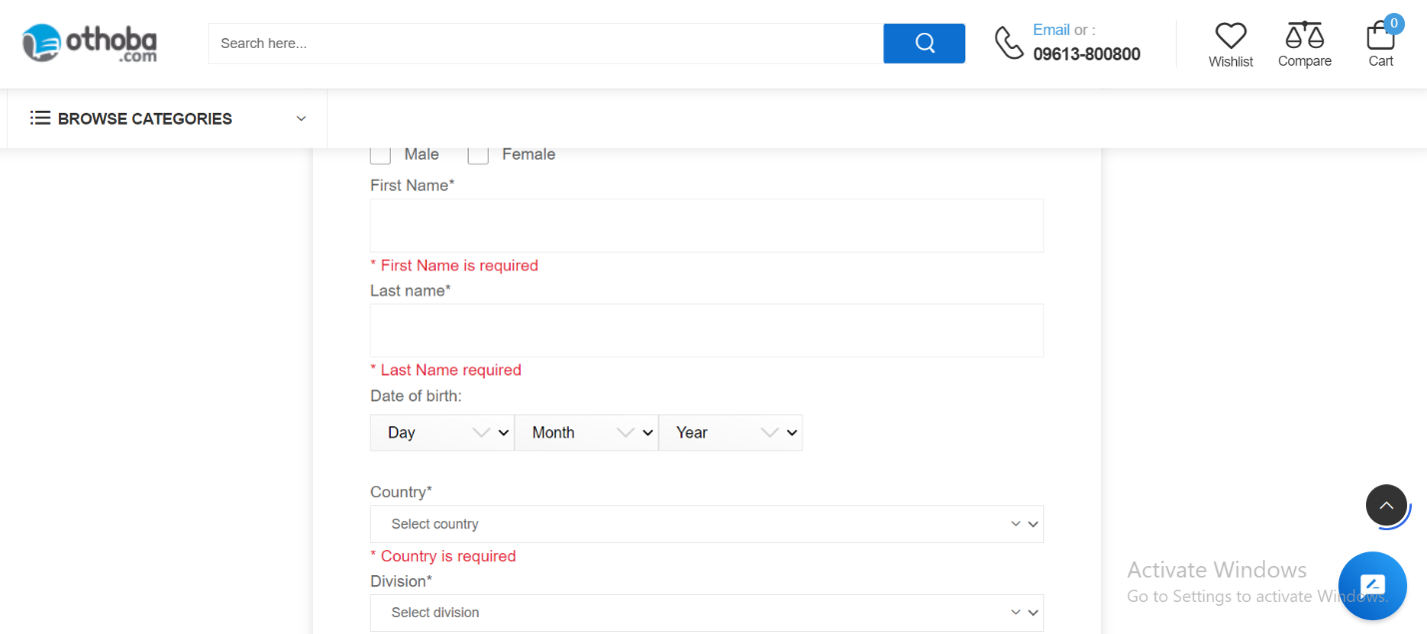

**2. Create an issue, consisting with Project name, Issue type, Summary, Description, Assignee, Reporter, Attachment screenshots of bug and click on the Create button in JIRA.**

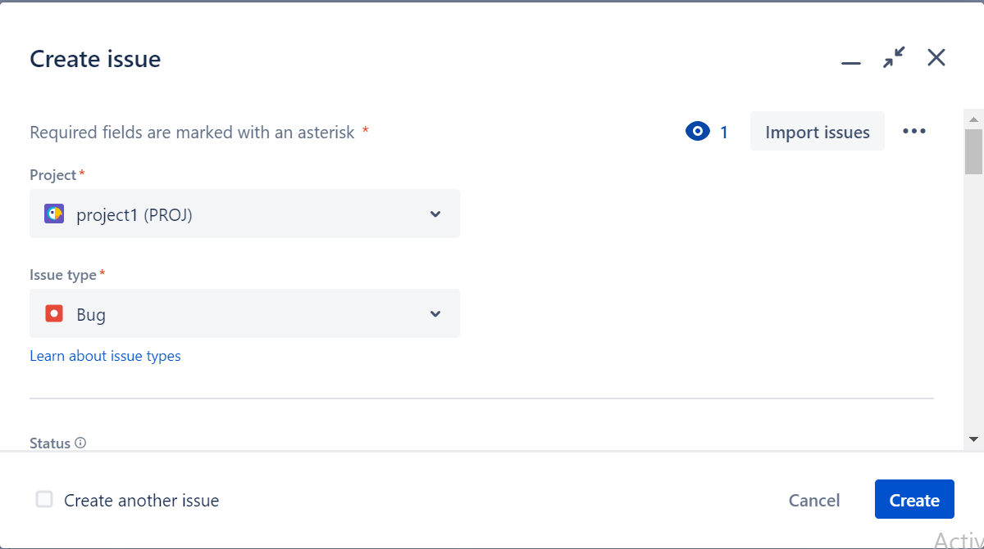

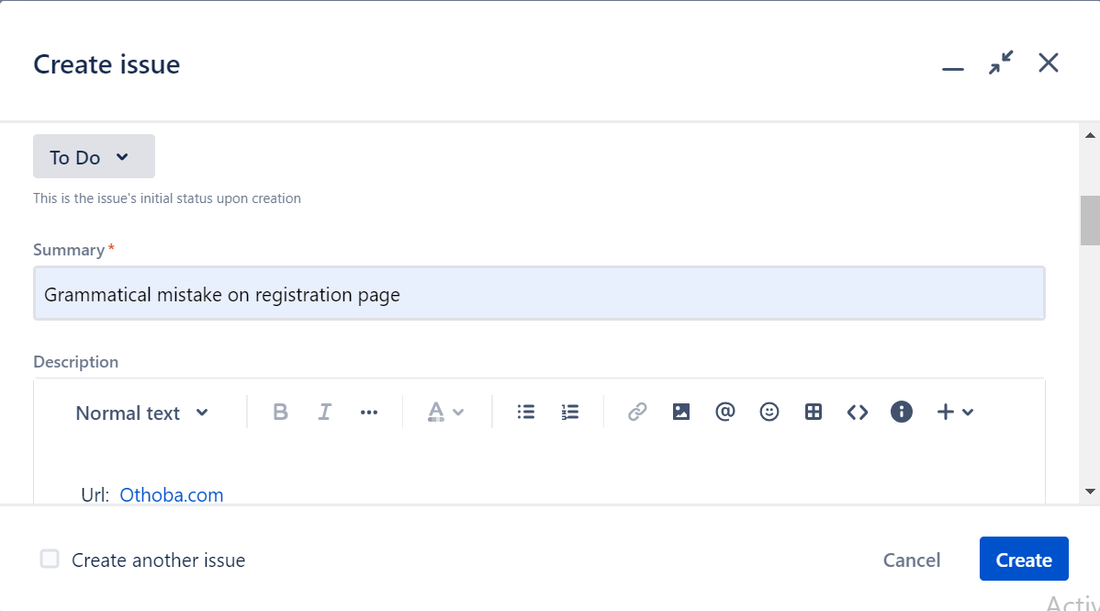

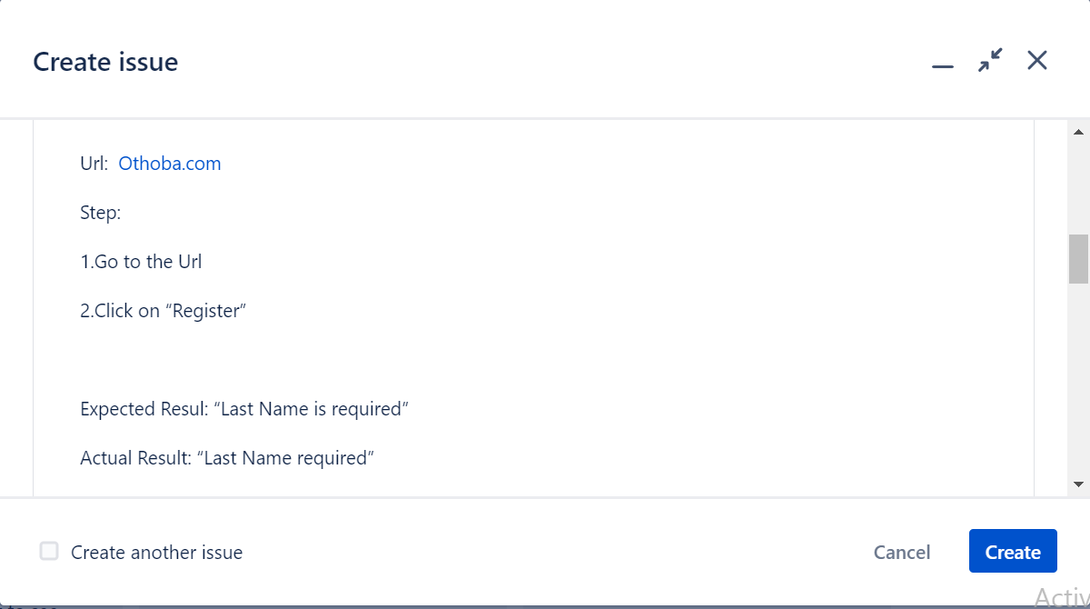

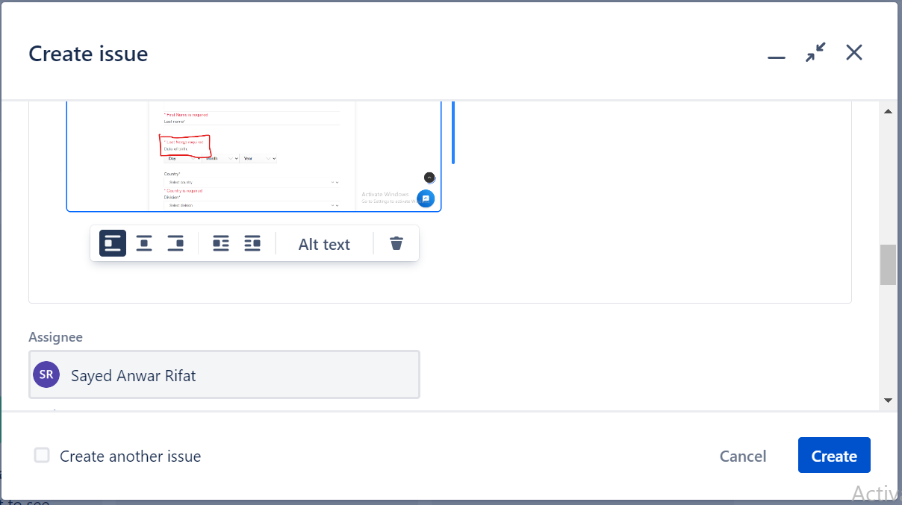

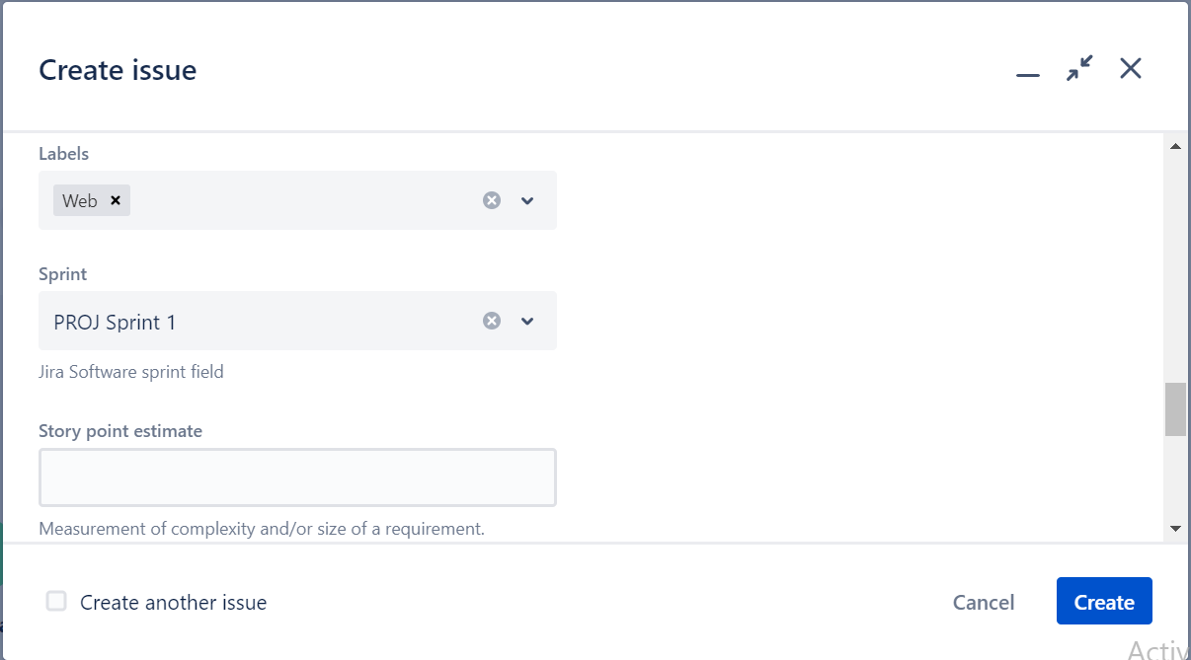

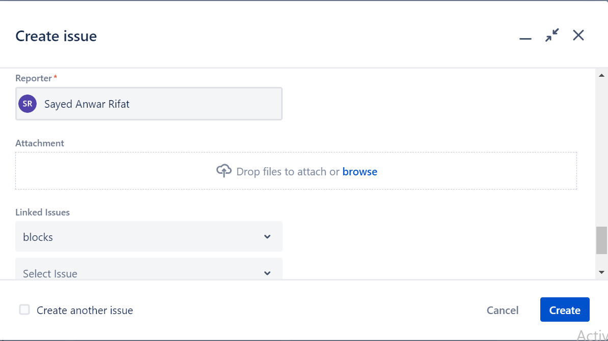

**3.Start a Sprint**

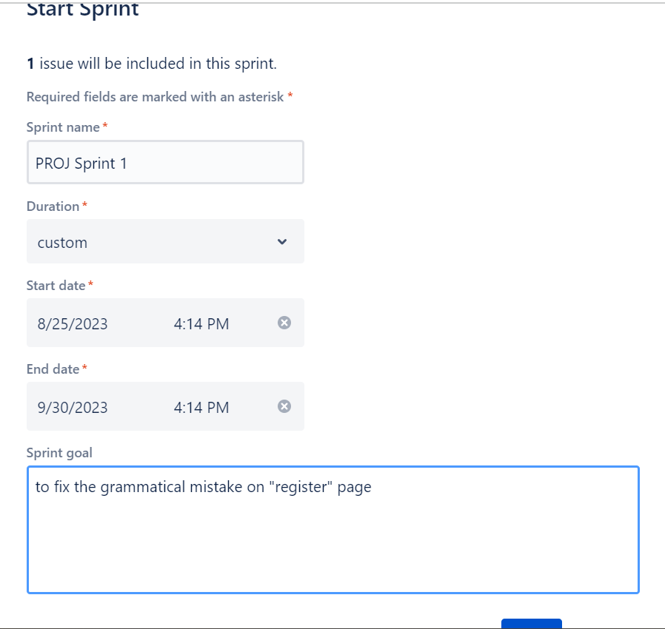

**4. Issue the sprint to the developers.**

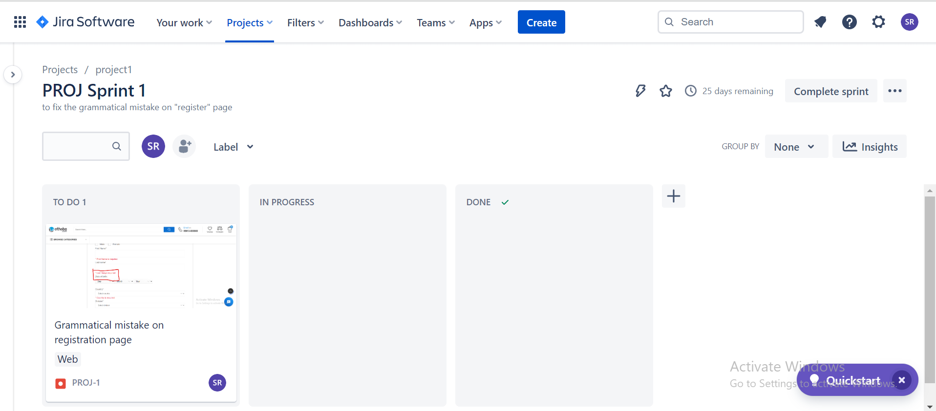

**5.In Progress**

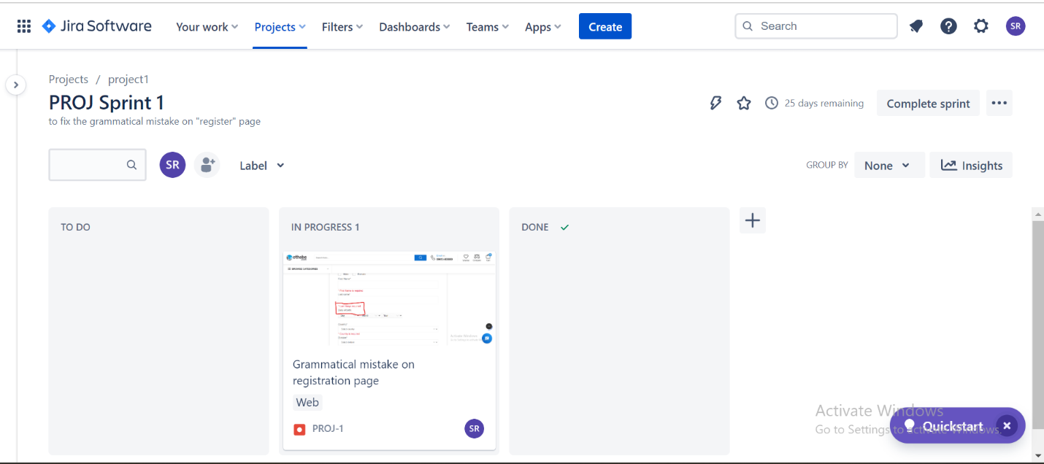

**6.Done when the issue fixed**

